IB Topics Summer Assignment – Rights & Protest United States, 1954-1965

Dear IB Topics Students:
Welcome! We will hit the ground running in August and I need you to begin the skill acquisition necessary to succeed in IB Topics; therefore, you will find source analysis activities on the following pages coupled with short videos from YouTube. Your work on these documents and videos will enable us to evaluate where we are as a class and what actions need to taken to get us where we need to be.
At the end of the packet are essay prompts on Civil Rights; the knowledge YOU gain this summer AND during our first school will be tested within the first two weeks of school by responding to ONE of the ten prompts in an essay. Our prewriting activity will assist me in tailoring instruction for the class. Enjoy your summer and I may be reached @ depielmeier@fcps.edu if you have any questions or concerns.

DUE DATE: 1st Friday of the School Year @ 310pm – 100 points Formative Assessment

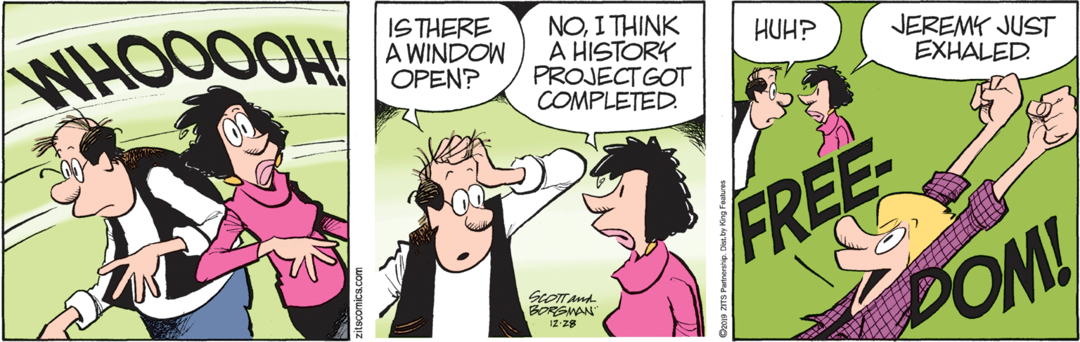
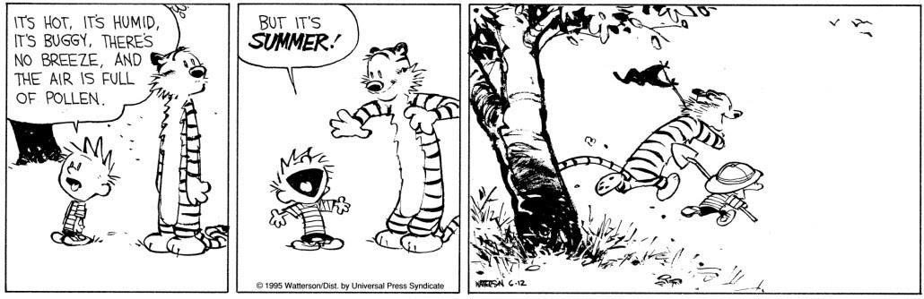

https://www.comicskingdom.com/zits?gclid=EAIaIQobChMIusOvnNnY5gIVjJ-zCh2qAgjCEAAYASAAEgKqdfD_BwE (December 28, 2019) and https://www.google.com/search?rlz=1C1CHZL_enUS713US713&tbm=isch&q=summer+fun+calvin+and+hobbes&chips=q:summer+fun+calvin+and+hobbes,online_chips:summer+vacation&usg=AI4_-kQp8qFzInyQvQP3LJ61sZrqzK-rxg&sa=X&ved=0ahUKEwjSxLXCzdbmAhWRg-AKHeMsDW4Q4lYILSgD&biw=1366&bih=625&dpr=1#imgrc=T1cMcxnsHBZH3M: (December 27, 2019)
RIGHTS & PROTEST: Case study 1: Civil rights movement in the United States (1954–1965)
Nature and characteristics of discrimination
- Racism and violence against African Americans; the Ku Klux Klan; disenfranchisement
- Segregation and education; Brown versus Board of Education decision (1954); Little Rock (1957)
- Economic and social discrimination; legacy of the Jim Crow laws; impact on individuals
Protests and action
- Non-violent protests; Montgomery bus boycott (1955–1956); Freedom Rides (1961); Freedom Summer (1964)
- Legislative changes: Civil Rights Act (1964); Voting Rights Act (1965)
The role and significance of key actors/groups
- Key actors: Martin Luther King Jr; Malcolm X; Lyndon B Johnson
- Key groups: National Association for the Advancement of Colored
- People (NAACP); Southern Christian Leadership Conference (SCLC) and Student Non-violent Coordinating Committee (SNCC); the Nation of Islam (Black Muslims)
Paper 1: A Source Paper in which students analyze 4 different sources in 4 questions [60minute time limit]
Question 1 [5 marks]: This question tests comprehension of sources – it will ask you to state clearly what source is saying – do not use direct quotes only => otherwise, the examiner will never know you have actually understood. In this question, one mark = one point.  Do not use dot points!
- Part A (3) – write firstly…, secondly, …thirdly to ensure that you make at least 3 separate points
  - Do not repeat
  - Do not OVERLY rely on quotes—make your point + briefly quote 2-3 words of the source in support
- Part B (2) – try to make two clear points and for each point refer specifically to the content of the source to provide evidence for your answer
‍
Question 2 [4 marks]: This question asks you to be an historian [synthesis + evaluation] => you must discuss origin + purpose in the first sentence. The value + limitation of the source must be analyzed with reference to its origin + purpose => context is not an issue.
- Provenance of the source provides origin [who wrote it? When did they write it? Where did they write it? What is the source [type]? + purpose Why did they write it? For whom (what audience) did they write it?
  - VALUE/LIMITATION – the type of source provides GENERIC/GENERAL points that may be applied to the source; however, your contextual knowledge and the specific provenance of the source will allow you to make much more PRECISE comments on the value and limitations
  - Content – what information are YOU EXTRACTING from the source and how is that information being presented by the author/source for VALUE + LIMITATION?
  - Please note that for evaluative purposes a source does not have more or less value if it is primary/secondary; rather, our evaluation rests upon its OPcVL!

Mark | Level Descriptor
4 | There is evaluation of the sources and explicit reference to their origin, purpose, value and limitation.
2-3 | There is some evaluation of the sources but reference to their origin, purpose, value and limitation may be limited.
1 | The sources are described but there is no reference to their origin, purpose, value and limitation.
0 | There is no description or evaluation of the sources.

A “formulaic” response to OPcVL would/could/should follow as outlined below
- 1st sentence – link origin and purpose
- 2nd sentence – transition from O/P to VALUE drawn from either type of source or content
- 3rd sentence – VALUE drawn from either type of source or content
- 4th Sentence – LIMIT drawn from either type of source or content, if focusing on source type may included critique of Origin/Purpose
- 5th Sentence – Limit drawn from either type of source or content

Question 3 [6 marks] Compare/Contrast: This question will ask you to examine the similarities, differences OR similarities AND differences between 2 sources [application + interpretation]. The wording changes + you need to work it out which it is asking you to do. Never deal with the sources separately [think BRAIDS]! Always make sure you restrict yourself to discussion of the specific issue it asks you to.
- Aim is to identify similar themes and ideas as well as differences between the 2 sources
- Key = LINKAGE!! One is expected to discuss the sources TOGETHER
- Examiner is looking for a running commentary
- Compare then Contrast
- Might not always be a balance of 3 comparisons and 3 contrasts, take what the documents give you.
- Always wrote in prose, do not make charts, grids or bullet points

Mark | Level descriptor – Question 3: Compare and Contrast
5-6 | - There is discussion of both sources. Explicit links are made between the two sources.  - The response includes clear and valid points of comparison and of contrast.
3-4 | - There is some discussion of both sources, although the two sources may be discussed separately.  - The response includes some valid points of comparison and/or of contrast, although these points may lack clarity.
1-2 | - There is superficial discussion of one or both sources.  - The response consists of description of the content of the source(s), and/or general comments about the source(s), rather than valid points of comparison or of contrast.
0 | - Response does not reach a standard described by the descriptors above.

Question 4 [9 marks]: Q4 is an essay [mini-essay @ 3 ¶…synthesis + evaluation] + you must make an argument in response to the question · You must also use both material from the sources and your own knowledge to develop a supported argument specific to the prompt => always note when you are using material from sources usually with ( ).
A ¶ ≠ Essay…
- Take a moment to make a brief plan based on the sources and YOUR knowledge
- You MUST use the sources in your essay
- Try to use ALL of the sources
- Include your own DETAILED knowledge
- Brief Introduction + Conclusion

Mark | Level descriptor—Question 4: Essay (SL& HL)
7–9 | The response is focused on the question. Clear references are made to the sources, and these references are used effectively as evidence to support the analysis. Accurate and relevant own knowledge is demonstrated. There is effective synthesis of own knowledge and source material.
4–6 | The response is generally focused on the question. References are made to the sources, and these references are used as evidence to support the analysis. Where own knowledge is demonstrated, this lacks relevance or accuracy. There is little or no attempt to synthesize own knowledge and source material.
1–3 | The response lacks focus on the question. References to the sources are made, but at this level these references are likely to consist of descriptions of the content of the sources rather than the sources being used as evidence to support the analysis. No own knowledge is demonstrated or, where it is demonstrated, it is inaccurate or irrelevant.
0 | The response does not reach a standard described by the descriptors below.

It’s all about how USEFUL the sources are as historical documents.
YouTube “Lectures” + Paper 1 Questions

Eyes on the Prize [multiple chapters on the Civil Rights Movement—refer to the subject guide on page for which episodes to emphasize.

David Halberstam's The Fifties: "THE RAGE WITHIN" https://www.youtube.com/watch?v=fVFdoiIpN_U @ 45 min a look at the Civil Rights Movement from Emmett Till to Little Rock and beyond (references Ralph Ellison’s Invisible Man as well as examines Bill Russell’s life.

Civil Rights and the 1950s: Crash Course US History #39
https://www.youtube.com/watch?v=S64zRnnn4Po 11:58
Brown v Board of Education (1954)

Brown v. Board of Education | Homework Help from the Bill of Rights Institute https://www.youtube.com/watch?v=1siiQelPHbQ 4:08

- Compare and contrast the views expressed in Sources A and B regarding reaction to the Brown v Board of Education decision in 1954. (6 marks)

Source A: “Emancipation”
The Supreme Court’s resolution yesterday of the school segregation cases affords all Americans an occasion for pride and gratification. The decision will prove, we are sure—whatever transient difficulties it may create and whatever irritations it may arouse—a profoundly healthy and healing one. It will serve—and speedily—to close an ancient wound too long allowed to fester. It will bring to an end a painful disparity between American principles and American practices. It will help to refurbish American prestige in a world which looks to this land for moral inspiration and restore the faith of Americans themselves in their own great values and traditions. --The Washington newspaper, Post and Times Herald, May 18, 1954
Source B: “Bloodstains on White Marble Steps”
Human blood may stain Southern soil in many places because of this decision but the dark red stains of that blood will be on the steps of the United States Supreme Court building…White and Negro children in the same schools will lead to miscegenation [a derogatory, insulting term for sexual relations between people of different races]. Miscegenation leads to mixed marriages and mixed marriages lead to mongrelization [the mixing, usually applied to dogs] of the human race.
--Daily News (Jackson, Mississippi)," May 18, 1954

Massive Resistance – Massive Resistance in Virginia https://www.youtube.com/watch?v=jwXwm39j82M 4:57
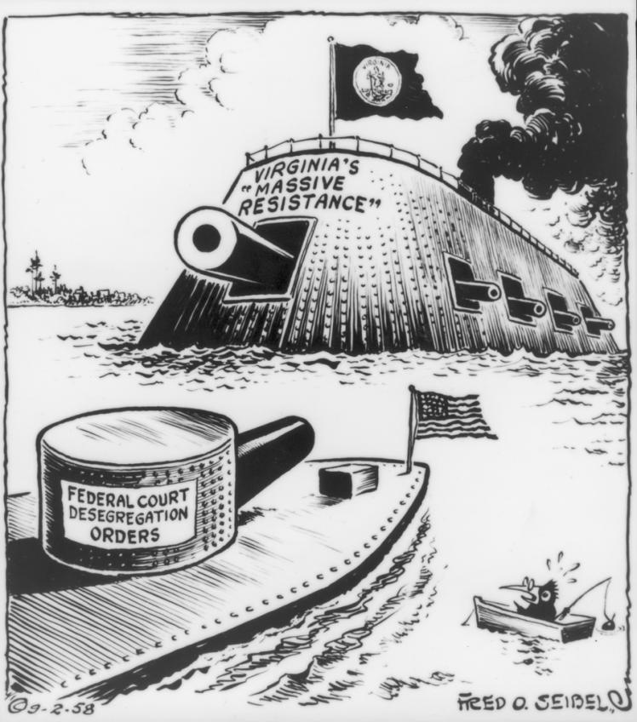
Source C
- What is the message conveyed by Source C?
Montgomery Bus Boycott https://www.youtube.com/watch?v=lHFPH79Iaoo 7:12

- (a) According to Source D, what are the causes of the Montgomery Bus Boycott. (3 marks)
Source D:
Dr. Martin Luther King spoke to nearly 5,000 people at the Holt Street Baptist Church in Montgomery on December 5, 1955, just four days after Mrs. Rosa Parks was arrested for refusing to relinquish her seat on a Montgomery city bus.
“But we are here in a specific sense, because of the bus situation in Montgomery. We are here because we are determined to get the situation corrected. This situation is not at all new. The problem has existed over endless years. For many years now Negroes in Montgomery and so many other areas have been inflicted with the paralysis of crippling fears on buses in our community. On so many occasions, Negroes have been intimidated and humiliated and impressed-oppressed-because of the sheer fact that they were Negroes. I don't have time this evening to go into the history of these numerous cases. Many of them now are lost in the thick fog of oblivion but at least one stands before us now with glaring dimensions.
Just the other day, just last Thursday to be exact, one of the finest citizens in Montgomery not one of the finest Negro citizens, but one of the finest citizens in Montgomery-was taken from a bus and carried to jail and because she refused to get up to give her seat to a white person. Now the press would have us believe that she refused to leave a reserved section for Negroes but I want you to know this evening that there is no reserved section. The law has never been clarified at that point. Now I think I speak with, with legal authority-not that I have any legal authority, but I think I speak with legal authority behind me -that the law, the ordinance, the city ordinance has never been totally clarified.
And you know, my friends, there comes a time when people get tired of being trampled over by the iron feet of oppression. There comes a time, my friends, when people get tired of being plunged across the abyss of humiliation, where they experience the bleakness of nagging despair. There comes a time when people get tired of being pushed out of the glittering sunlight.”

Freedom Rides https://www.youtube.com/watch?v=1zBY6gkpbTg 5:03
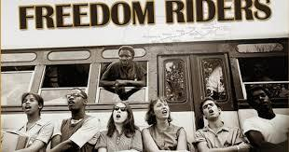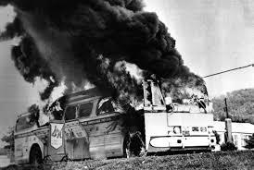

Source E Source F

What are the messages conveyed by Sources E & F? [2 marks each]

The 1964 Freedom Summer Documentary https://www.youtube.com/watch?v=-PFc3wkkpDY 11:43

- With reference to its origin, purpose and content, analyze the value and limitations of Source G for a historian studying the Civil Rights Movements in the United States. [4 marks]

Source G
Extract from The Civil Rights Movement by Charles Patterson, New York, 1995 (an American historian) (an academic text)
Freedom Summer was designed to register blacks for a real election – the 1964 presidential election. The ambitious goals of the project were to register as many blacks as possible across the state; organize a “Freedom Democratic Party” to challenge the official whites-only Mississippi Democratic Party; set up ‘freedom schools” for black children and establish community centers for blacks who needed medical or legal help. Student volunteers were recruited at elite colleges in the Northeast, large universities in the Midwest and black colleges in the South… The day after the first wave of about 200 students arrived in Mississippi – three young civil rights workers disappeared…The disappearance of the civil rights workers failed to deter the work of the Freedom Summer volunteers, nor did the arrests, shootings and burnings of churches that served as “freedom schools.”…
The most dramatic result of the Freedom Summer was the creation of the Mississippi Freedom Democratic Party (MFDP). Organized by the Student Nonviolent Coordinating Committee (SNCC) to challenge the legitimacy and supremacy of Mississippi’ all-white regular Democratic Party. Freedom Summer volunteers convinced 80,000 blacks to join MFDP…Although the MFDP was never officially recognized by the state Democratic party, its dramatic challenge marked the beginning of the end of exclusive white political control of the state… Freedom Summer was also important for the civil rights movement itself because it moved the struggle to a new level, beyond the bus boycotts, freedom rides and sit-ins. Mississippi blacks demonstrated to the nation that they wanted to vote, elect representatives, and have a voice in government. They wanted the political power they were entitled to as American citizens, black people were fighting for more than a seat at the lunch counter, they were now fighting for seats in the legislature.

The March on Washington The March (1963, restored) National Archives
https://www.youtube.com/watch?v=DQYzHIIQ1O4 33:31

- With reference to its origin, purpose and content, analyze the value and limitations of Source H for a historian studying the Civil Rights Movements in the United States. [4 marks]

Source H: Martin Luther King's I have a dream speech August 28 1963

I am happy to join with you today in what will go down in history as the greatest demonstration for freedom in the history of our nation.
Five score years ago, a great American, in whose symbolic shadow we stand today, signed the Emancipation Proclamation. This momentous decree came as a great beacon light of hope to millions of Negro slaves who had been seared in the flames of withering injustice. It came as a joyous daybreak to end the long night of captivity.
But one hundred years later, the Negro still is not free. One hundred years later, the life of the Negro is still sadly crippled by the manacles of segregation and the chains of discrimination. One hundred years later, the Negro lives on a lonely island of poverty in the midst of a vast ocean of material prosperity. One hundred years later, the Negro is still languished in the corners of American society and finds himself in exile in his own land. So we have come here today to dramatize an shameful condition.
In a sense we've come to our nation's Capital to cash a check. When the architects of our republic wrote the magnificent words of the Constitution and the Declaration of Independence, they were signing a promissory note to which every American was to fall heir.
This note was a promise that all men, yes, black men as well as white men, would be guaranteed the unalienable rights of life, liberty, and the pursuit of happiness.
It is obvious today that America has defaulted on this promissory note insofar as her citizens of color are concerned. Instead of honoring this sacred obligation, America has given the Negro people a bad check; a check which has come back marked "insufficient funds."
But we refuse to believe that the bank of justice is bankrupt. We refuse to believe that there are insufficient funds in the great vaults of opportunity of this nation. So we have come to cash this check- a check that will give us upon demand the riches of freedom and the security of justice.
We have also come to this hallowed spot to remind America of the fierce urgency of now. This is no time to engage in the luxury of cooling off or to take the tranquilizing drug of gradualism.
Now is the time to make real the promises of democracy. Now is the time to rise from the dark and desolate valley of segregation to the sunlit path of racial justice. Now is the time to lift our nation from the quicksands of racial injustice to the solid rock of brotherhood. Now is the time to make justice a reality for all of God's children.
It would be fatal for the nation to overlook the urgency of the moment. This sweltering summer of the Negro's legitimate discontent will not pass until there is an invigorating autumn of freedom and equality. Nineteen sixty-three is not an end, but a beginning. Those who hope that the Negro needed to blow off steam and will now be content will have a rude awakening if the nation returns to business as usual. There will be neither rest nor tranquility in America until the Negro is granted his citizenship rights. The whirlwinds of revolt will continue to shake the foundations of our nation until the bright day of justice emerges.
But there is something that I must say to my people who stand on the warm threshold which leads into the palace of justice. In the process of gaining our rightful place we must not be guilty of wrongful deeds. Let us not seek to satisfy our thirst for freedom by drinking from the cup of bitterness and hatred. We must forever conduct our struggle on the high plane of dignity and discipline. We must not allow our creative protest to degenerate into physical violence. Again and again we must rise to the majestic heights of meeting physical force with soul force.
The marvelous new militancy which has engulfed the Negro community must not lead us to a distrust of all white people, for many of our white brothers, as evidenced by their presence here today, have come to realize that their destiny is tied up with our destiny. And they have come to realize that their freedom is inextricably bound to our freedom. We cannot walk alone.
And as we walk, we must make the pledge that we shall march ahead. We cannot turn back. There are those who are asking the devotees of civil rights, "When will you be satisfied?"
We can never be satisfied as long as the Negro is the victim of the unspeakable horrors of police brutality.
We can never be satisfied as long as our bodies, heavy with the fatigue of travel, cannot gain lodging in the motels of the highways and the hotels of the cities.
We cannot be satisfied as long as the Negro's basic mobility is from a smaller ghetto to a larger one.
We can never be satisfied as long as our children are stripped of their selfhood and robbed of their dignity by signs stating "for whites only."
We cannot be satisfied as long as a Negro in Mississippi cannot vote and a Negro in New York believes he has nothing for which to vote.
No, no, we are not satisfied, and we will not be satisfied until justice rolls down like waters and righteousness like a mighty stream.
I am not unmindful that some of you have come here out of great trials and tribulations. Some of you have come fresh from narrow jail cells. Some of you have come from areas where your quest for freedom left you battered by the storms of persecution and staggered by the winds of police brutality. You have been the veterans of creative suffering. Continue to work with the faith that unearned suffering is redemptive.
Go back to Mississippi, go back to Alabama, go back to South Carolina, go back to Georgia, go back to Louisiana, go back to the slums and ghettos of our northern cities, knowing that somehow this situation can and will be changed. Let us not wallow in the valley of despair.
I say to you today, my friends, so even though we face the difficulties of today and tomorrow, I still have a dream. It is a dream deeply rooted in the American dream.
I have a dream that one day this nation will rise up and live out the true meaning of its creed: "We hold these truths to be self-evident; that all men are created equal."
I have a dream that one day on the red hills of Georgia the sons of former slaves and the sons of former slave owners will be able to sit down together at the table of brotherhood.
I have a dream that one day even the state of Mississippi, a state sweltering with the heat of injustice, sweltering with the heat of oppression, will be transformed into an oasis of freedom and justice.
I have a dream that my four little children will one day live in a nation where they will not be judged by the color of their skin but by the content of their character.
I have a dream today.
I have a dream that one day down in Alabama, with its vicious racists, with its governor having his lips dripping with the words of interposition and nullification, that one day right down in Alabama little black boys and black girls will be able to join hands with little white boys and white girls as sisters and brothers.
I have a dream today.
I have a dream that one day every valley shall be exhalted, every hill and mountain shall be made low, the rough places will be made plain, and the crooked places will be made straight, and the glory of the Lord shall be revealed, and all flesh shall see it together.
This is our hope. This is the faith that I will go back to the South with. With this faith we will be able to hew out of the mountain of despair a stone of hope. With this faith we will be able to transform the jangling discords of our nation into a beautiful symphony of brotherhood.
With this faith we will be able to work together, to pray together, to struggle together, to go to jail together, to stand up for freedom together, knowing that we will be free one day.
This will be the day when all of God's children will be able to sing with new meaning, "My country 'tis of thee, sweet land of liberty, of thee I sing. Land where my fathers died, land of the Pilgrims' pride, from every mountainside, let freedom ring."
And if America is to be a great nation, this must become true. So let freedom ring from the prodigious hilltops of New Hampshire. Let freedom ring from the mighty mountains of New York. Let freedom ring from the heightening Alleghenies of Pennsylvania.
Let freedom ring from the snow-capped Rockies of Colorado. Let freedom ring from the curvaceous slopes of California. But not only that; let freedom ring from the Stone Mountain of Georgia. Let freedom ring from Lookout Mountain of Tennessee.
Let freedom ring from every hill and molehill of Mississippi. From every mountainside, let freedom ring.
And when this happens, and when we allow freedom ring, when we let it ring from every village and every hamlet, from every state and every city, we will be able to speed up that day when all of God's children, black men and white men, Jews and gentiles, Protestants and Catholics, will be able to join hands and sing in the words of the old Negro spiritual, "
Free at last! Free at last! Thank God Almighty, we are free at last!

The 1964 Civil Rights Bill Explained in 8 Minutes https://www.youtube.com/watch?v=bVMH5u6bPGA 8:25
- (a) According to Source I, in what ways did the Civil Rights Act of 1964 extend protections to all Americans? (3 marks)

Source I: Public Law 88-352, Civil Rights Act of 1964, passed July 2, 1964
To enforce the constitutional right to vote, to confer jurisdiction upon the district courts of the United States to provide injunctive relief against discrimination in public accommodations, to authorize the Attorney General to institute suits to protect constitutional rights in public facilities and public education, to extend the Commission on Civil Rights, to prevent discrimination in federally assisted programs, to establish a Commission on Equal Employment Opportunity, and for other purposes.
Be it enacted by the Senate and House of Representatives of the United States of America in Congress assembled, That this Act may be cited as the "Civil Rights Act of 1964".

Selma : The Real Selma Footage
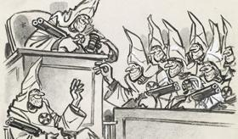
https://www.youtube.com/watch?v=smx-Sk3PzzI 12:21

Source J

“A GUY’S ENTITLED TO A JURY OF HIS PEERS, AIN’T HE?”
Herblock sympathized with Alabama State Attorney General Richmond M. Flowers (1918–2007). Flowers faced the challenge of finding jurors who did not proudly espouse white supremacist views when Collie Leroy Wilkins, Jr., (1945–1994) went to trial for the murder of Viola Gregg Liuzzo (1925–1965), a white civil rights activist who had participated in the march from Selma to Montgomery, Alabama. Prosecutors in Hayneville, Alabama, had found it difficult to convict other Ku Klux Klan members for their roles in the death of other white protest marchers. Initially acquitted on state charges, Wilkins was later convicted in a federal court and served seven years for depriving Liuzzo of her civil rights.
- What is the message conveyed by the image in Source J?
President Johnson and the Voting Rights Act of 1965 https://www.youtube.com/watch?v=-AN4NZSROvs 8:01

A History of Voting Rights | The New York Times https://www.youtube.com/watch?v=U4XtZ-tIzIA 3:19
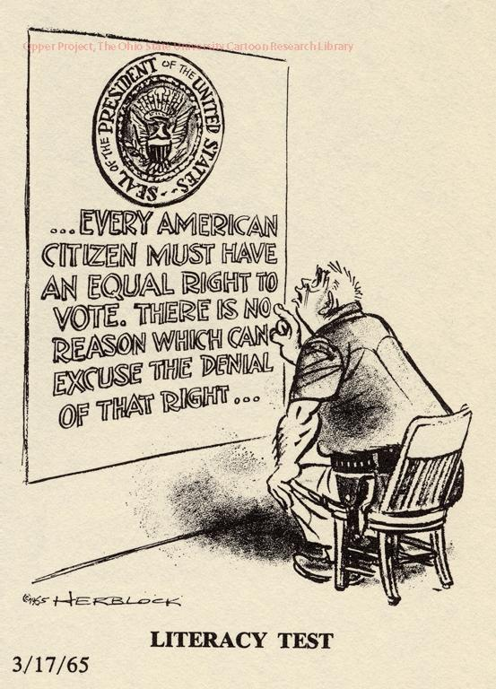
Source K
What is the message conveyed by Source K (2 marks)?

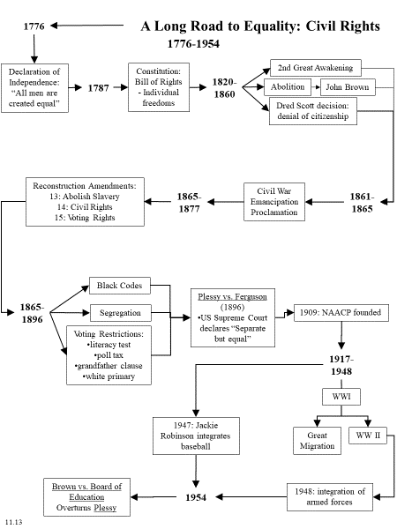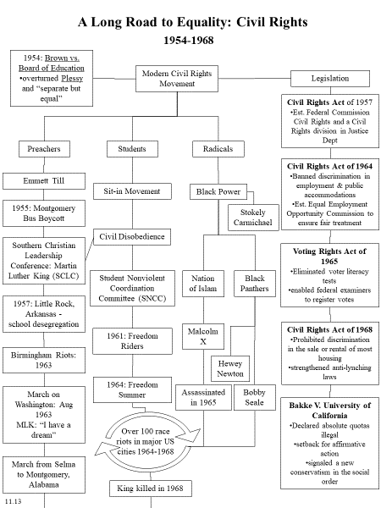

Essay Prompts for Evaluative Essay to be delivered within the first two weeks of class…ONE of the following will be selected and students will have to respond.
- How did the African American Civil Rights movement of the 1950s and 1960s address the failures of Reconstruction?
- Analyze the extent to which the Civil Rights Movement transformed American society in the 1950s and 1960s.
- Analyze the successes and failures of the United States’ Civil Rights movement between 1954 and 1964.
- In what ways, and for what reasons, did the African American struggle for civil rights in the United States change between the early and late 1960s?
- In what ways, and for what reasons, did the civil rights movement in the United States make significant progress in the period 1950 to 1964?
- Explain why and how the Civil Rights movement became more radical as the 1960s progressed.
- To what extent had African Americans in the United States gained their civil and political rights by 1968?
- How successful were United States governmental institutions in advancing civil rights for African Americans after 1945?
- To what extent can Martin Luther King be said to have achieved his goals in the Civil Rights Movement?
- To what extent did the civil rights movement in the US end segregation in the South between 1955 and 1980?

Common IB Command terms for Humanities
Analyze | Break down in order to bring out the essential elements or structure.
Compare | Give an account of the similarities between two (or more) items or situations, referring to both (all) of them throughout.
Compare & Contrast | Give an account of similarities and differences between two (or more) items or situations, referring to both (all) of them throughout.
Contrast | Give an account of the differences between two (or more) items or situations, referring to both (all) of them throughout.
Discuss | Offer a considered and balanced review that includes a range of arguments, factors or hypotheses. Opinions or conclusions should be presented clearly and supported by appropriate evidence.
Evaluate | Make an appraisal by weighing up the strengths and limitations.
Examine | Consider an argument or concept in a way that uncovers the assumptions and interrelationships of the issue.
Reflect | Think about deeply; consider.
Synthesize | Combine different ideas and evidence in order to create new understanding.
To what extent | Consider the merits or otherwise of an argument or concept. Opinions and conclusions should be presented clearly and supported with appropriate evidence and sound argument.

FCPS % | Mark | Markbands -- Level descriptor (SL/HL)
1—50 | 1-3 | There is little understanding of the demands of the question. The answer is poorly structured or, where there is a recognizable essay structure, there is minimal focus on the task.  Little knowledge is present. Where specific examples are referred to, they are factually incorrect, irrelevant or vague.  The response contains little or no critical analysis. It may consist mostly of generalizations and poorly substantiated assertions.
2—55
3-60
4-70 | 4-6 | The response indicates some understanding of the demands of the question. While there may be an attempt to follow a structured approach, the response lacks clarity and coherence.  Knowledge is demonstrated but lacks accuracy and relevance. There is a superficial understanding of historical context. The answer makes use of specific examples, although these may be vague or lack relevance.  There is some limited analysis, but the response is primarily narrative/descriptive in nature, rather than analytical
5-75
6-79
7-82 | 7-9 | The response indicates an understanding of the demands of the question, but these demands are only partially addressed. There is an attempt to follow a structured approach.  Knowledge is mostly accurate and relevant. Events are generally placed in their historical context. Examples used are appropriate and relevant.  The response moves beyond description to include some analysis or critical commentary, but this is not sustained.
8-85
9-87
10-90 | 10-12 | The demands of the question are understood and addressed. Answers are generally well structured and organized, although there may be some repetition or lack of clarity in places.  Knowledge is accurate and relevant. Events are placed in their historical context, and there is a clear understanding of historical concepts. Examples used are appropriate and relevant, and are used to support the analysis/evaluation.  Arguments are mainly clear and coherent. There is some awareness and evaluation of different perspectives. (+/-)  The response contains critical analysis. Most of the main points are substantiated, and the response argues to a consistent conclusion.
11-93
12-95
13-98 | 13-15 | Responses are clearly focused, showing a high degree of awareness of the demands and implications of the question. Answers are well structured, balanced and effectively organized.  Knowledge is detailed, accurate and relevant. Events are placed in their historical context, and there is a clear understanding of historical concepts. Examples used are appropriate and relevant, and are used effectively to support the analysis/evaluation.  Arguments are clear and coherent. There is evaluation of different perspectives, and this evaluation is integrated effectively into the answer.  The answer contains well-developed critical analysis. All, or nearly all, of the main points are substantiated, and the response argues to a reasoned conclusion
14-100
15-100

BE PRECISE, BE RELEVANT, BE ANALYTICAL—EVIDENCE DRIVES ONE’S ARGUMENT!!!
Areas of Compliment/Concern:
++ | -- | Control over Argument (+)
Introduction/Thesis
- Tie 2 Prompt
- Strong Thesis [define parameters of response]
- Prepare reader for Essay
- Transition to Body
- Refine and Strengthen
- Demonstare Control from the Start
Analysis/Argument
- Muddled/Unsure
- Evidence not explained
- Well-developed Critical Analysis – YOUR VIEWS!
Evidence/Support
- Support assertions—strong, detailed—linked to thesis
- Lack of Detail
- Pay attention 2 Chronology
Conclusion
- Return 2 Prompt & Thesis
- POOR ORGANIZATION
Editorial Abbreviations:

AWK – awkward
Cite—cite your evidence/Source
E—evidence
Frag – Sentence Fragment
Org—Organization Issues
NA = Not Exactly
PV—passive voice
RS—run-on sentence
Set the Stage – link intro to essay prompt
T—tense
WC—word choice

Make an appointment to see me to discuss your essay.
Please turn in work of a standard to which you are capable!!
A FINE READ, THANKS!!!
Revised November 30, 2018

Breakdown the Question into its COMMAND TERM and COMPONENTS

General Rules of Thumb:

- READ THE QUESTION!!!!!—break it down into its essential parts, READ THE QUESTION
- (HISTORY) Time/Place – inform the reader of relevant dates as well as where the writing occurs
- (English)How does style affect meaning?
- Proceed from the general to the specific
- Use No personal pronouns
- Never use slang
- Be consistent with tense
- Do not use contractions
- Do not ask rhetorical questions!!!!!!!!!!!!!!!!!!!!!!!!
- Due to speaks to a specific causal relationship not often found in history…use with extreme caution
- Avoid Qualifiers especially VERY
- Avoid Block Quotations—transform into YOUR own words
- Avoid Wordiness—eliminate ALL excess words
- think through and organize your thoughts
- write to persuade
- use adjectives to convey amount of generality or specificity
- test generalizations by thinking of arguments and counter-arguments
- Thesis Paragraph: clear, precise topic sentence...use question as your guide
- let your introduction lead into the body of your essay
- Conclusion should strengthen your essay, not undermine it
- Cite your work
- Capitalization matters
- First time full name (person), thereafter last name only
- First time full name (organization) with (…) thereafter example= Federal Bureau of Investigation (FBI)

Sentence Power:

Coordinating Conjunctions—use a comma when joining two sentences FANBOYS
- for, and, nor, but, or, yet, so
Correlative Conjunctions – always used in pairs
- both…and; not only…but also; neither…nor; whether…or
Subordinating Conjunctions—connect subordinate clauses to a main clause
- TIME: after, before, when, while, since, until
- CAUSE+ EFFECT: because, since, now that, as, in order that, so
- OPPOSITION: although, though, even though, whereas, while
- CONDITION: if, unless, only if, whether or not, even if, in case (that)
- after, although, as, as if, as long as, as though, because, before, even if, even though, if, if only, in order that, now that, once, rather than, since, so that, than, that, though, till, unless, until, when, whenever, where, whereas, wherever, while
Conjunctive Adverbs—connect two sentences, separated by a semicolon
- ADDITION: again, also, and, and then, besides, equally important, finally, first, further, furthermore, in addition, in the first place, last, moreover, next, second, still, too
- COMPARISON: also, in the same way, likewise, similarly
- CONCESSION: granted, naturally, of course
- CONTRAST: although, and yet, at the same time, but at the same time, despite that, even so, even though, for all that, however, in contrast, in spite of, instead, nevertheless, notwithstanding, on the contrary, on the other hand, otherwise, regardless, still, though, yet
- EMPHASIS: certainly, indeed, in fact, of course
- EXAMPLE or ILLUSTRATION: after all, as an illustration, even, for example, for instance, in conclusion, indeed, in fact, in other words, in short, it is true, of course, namely, specifically, that is, to illustrate, thus, truly
- SUMMARY: all in all, altogether, as has been said, finally, in brief, in conclusion, in other words, in particular, in short, in simpler terms, in summary, on the whole, that is, therefore, to put it differently, to summarize
- TIME SEQUENCE: after a while, afterward, again, also, and then, as long as, at last, at length, at that time, before, besides, earlier, eventually, finally, formerly, further, furthermore, in addition, in the first place, in the past, last, lately, meanwhile, moreover, next, now, presently, second, shortly, simultaneously, since, so far, soon, still, subsequently, then, thereafter, too, until, until now, when
Breakdown the Question into its COMMAND TERM and COMPONENTS

General Rules of Thumb:

- READ THE QUESTION!!!!!—break it down into its essential parts, READ THE QUESTION
- (HISTORY) Time/Place – inform the reader of relevant dates as well as where the writing occurs
- (English)How does style affect meaning?
- Proceed from the general to the specific
- Use No personal pronouns
- Never use slang
- Be consistent with tense
- Do not use contractions
- Do not ask rhetorical questions!!!!!!!!!!!!!!!!!!!!!!!!
- Due to speaks to a specific causal relationship not often found in history…use with extreme caution
- Avoid Qualifiers especially VERY
- Avoid Block Quotations—transform into YOUR own words
- Avoid Wordiness—eliminate ALL excess words
- think through and organize your thoughts
- write to persuade
- use adjectives to convey amount of generality or specificity
- test generalizations by thinking of arguments and counter-arguments
- Thesis Paragraph: clear, precise topic sentence...use question as your guide
- let your introduction lead into the body of your essay
- Conclusion should strengthen your essay, not undermine it
- Cite your work
- Capitalization matters
- First time full name (person), thereafter last name only
- First time full name (organization) with (…) thereafter example= Federal Bureau of Investigation (FBI)

Sentence Power:

Coordinating Conjunctions—use a comma when joining two sentences FANBOYS
- for, and, nor, but, or, yet, so
Correlative Conjunctions – always used in pairs
- both…and; not only…but also; neither…nor; whether…or
Subordinating Conjunctions—connect subordinate clauses to a main clause
- TIME: after, before, when, while, since, until
- CAUSE+ EFFECT: because, since, now that, as, in order that, so
- OPPOSITION: although, though, even though, whereas, while
- CONDITION: if, unless, only if, whether or not, even if, in case (that)
- after, although, as, as if, as long as, as though, because, before, even if, even though, if, if only, in order that, now that, once, rather than, since, so that, than, that, though, till, unless, until, when, whenever, where, whereas, wherever, while
Conjunctive Adverbs—connect two sentences, separated by a semicolon
- ADDITION: again, also, and, and then, besides, equally important, finally, first, further, furthermore, in addition, in the first place, last, moreover, next, second, still, too
- COMPARISON: also, in the same way, likewise, similarly
- CONCESSION: granted, naturally, of course
- CONTRAST: although, and yet, at the same time, but at the same time, despite that, even so, even though, for all that, however, in contrast, in spite of, instead, nevertheless, notwithstanding, on the contrary, on the other hand, otherwise, regardless, still, though, yet
- EMPHASIS: certainly, indeed, in fact, of course
- EXAMPLE or ILLUSTRATION: after all, as an illustration, even, for example, for instance, in conclusion, indeed, in fact, in other words, in short, it is true, of course, namely, specifically, that is, to illustrate, thus, truly
- SUMMARY: all in all, altogether, as has been said, finally, in brief, in conclusion, in other words, in particular, in short, in simpler terms, in summary, on the whole, that is, therefore, to put it differently, to summarize
- TIME SEQUENCE: after a while, afterward, again, also, and then, as long as, at last, at length, at that time, before, besides, earlier, eventually, finally, formerly, further, furthermore, in addition, in the first place, in the past, last, lately, meanwhile, moreover, next, now, presently, second, shortly, simultaneously, since, so far, soon, still, subsequently, then, thereafter, too, until, until now, when

Revised April 15, 2020

http://www.let.rug.nl/usa/documents/1951-/martin-luther-kings-i-have-a-dream-speech-august-28-1963.php (September 10, 2019)

